**Jemma Johnston**

**Cohort E20**

**PDA - Implementation & Testing Unit**

**IT:1** - **Demonstrate encapsulation in a program**

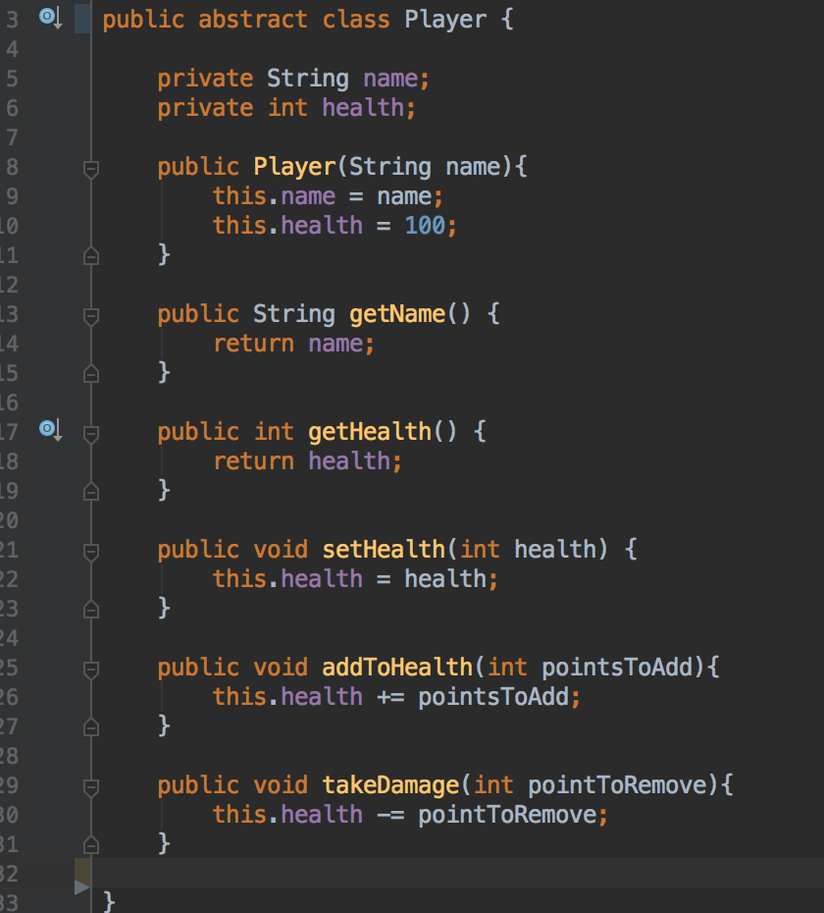

**IT:2** - **Use of inheritance in a program**

Showing use of getWeapon

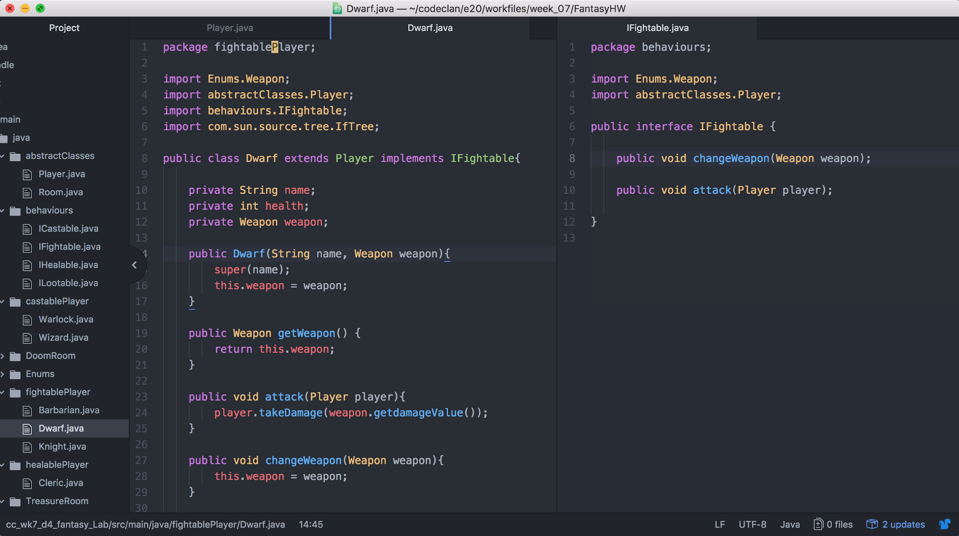

Wizard child class inherits from Player class. Child calls the Super method to access parent’s methods.



Object in inherited class. Method that uses info from inherited class.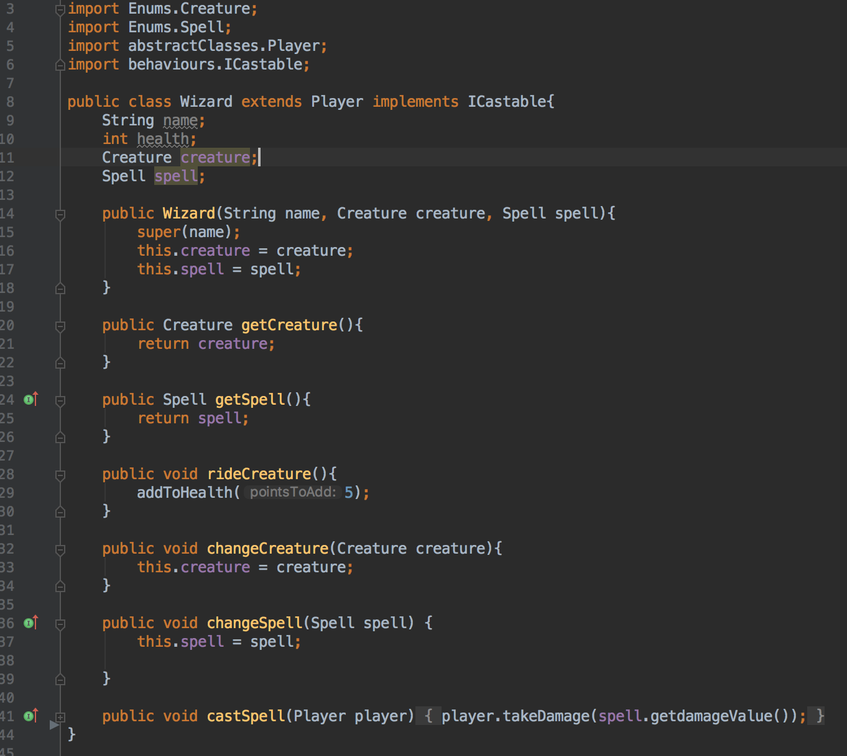

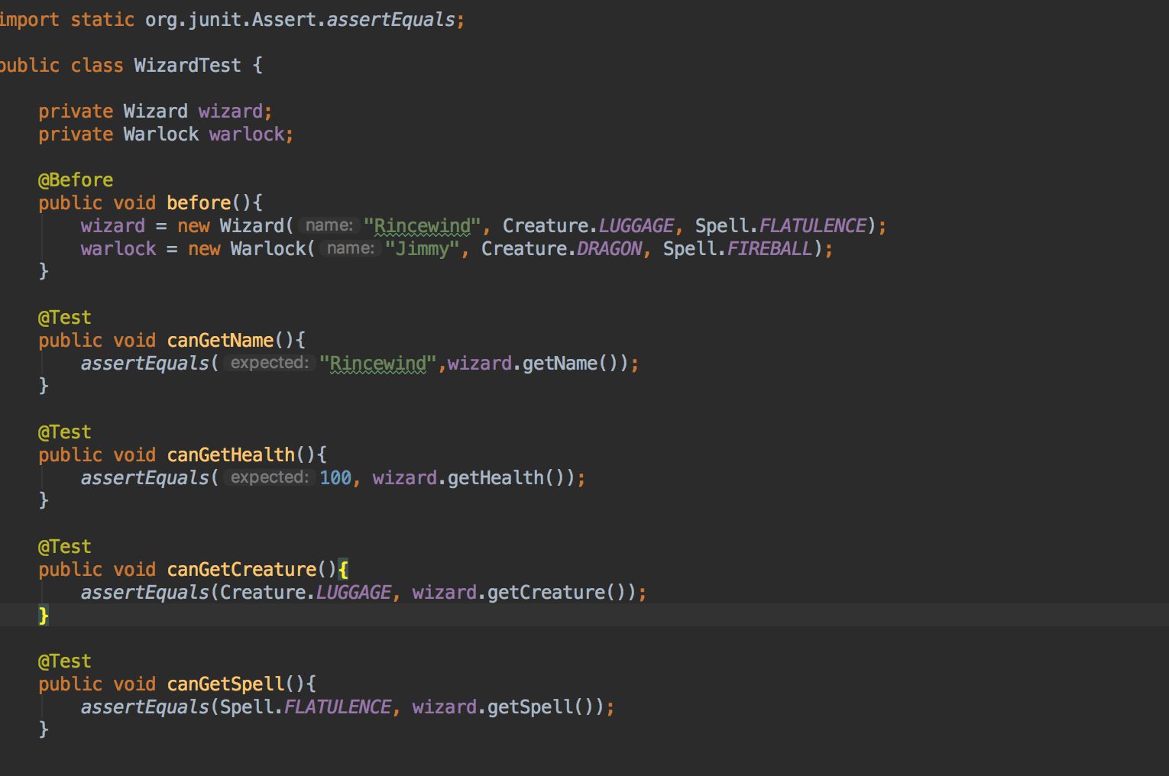

**IT:3 Demonstrate searching data in a program. Take screenshots of:**

● Function that searches data

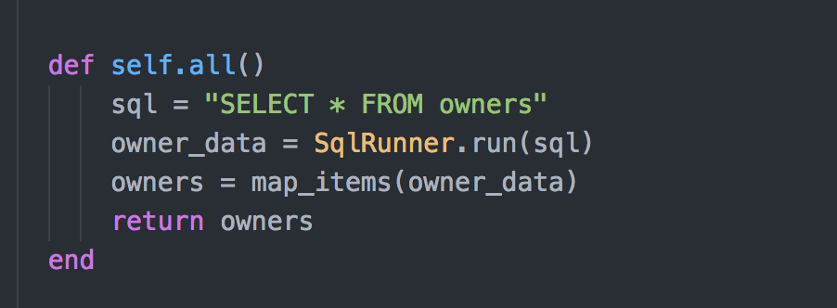

● The result of the function running

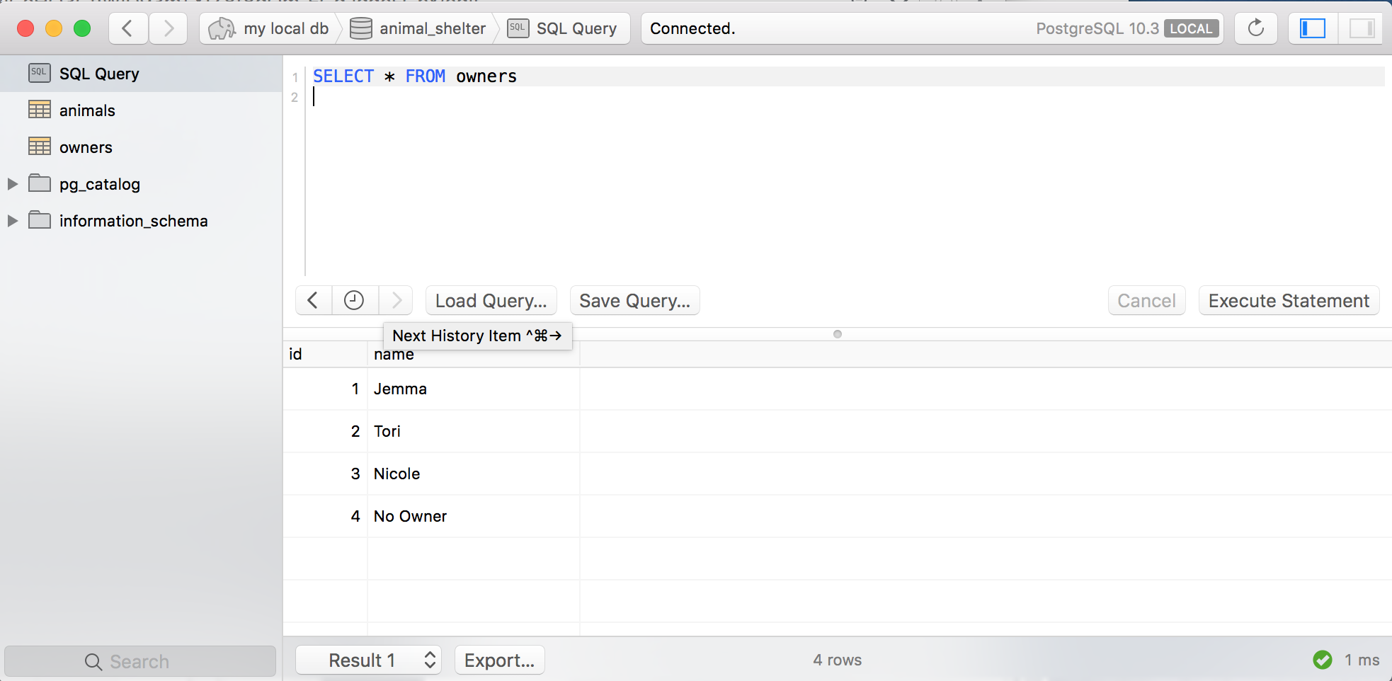

**IT:4 - Demonstrate sorting data in a program.**

● Function that sorts data ● The result of the function running

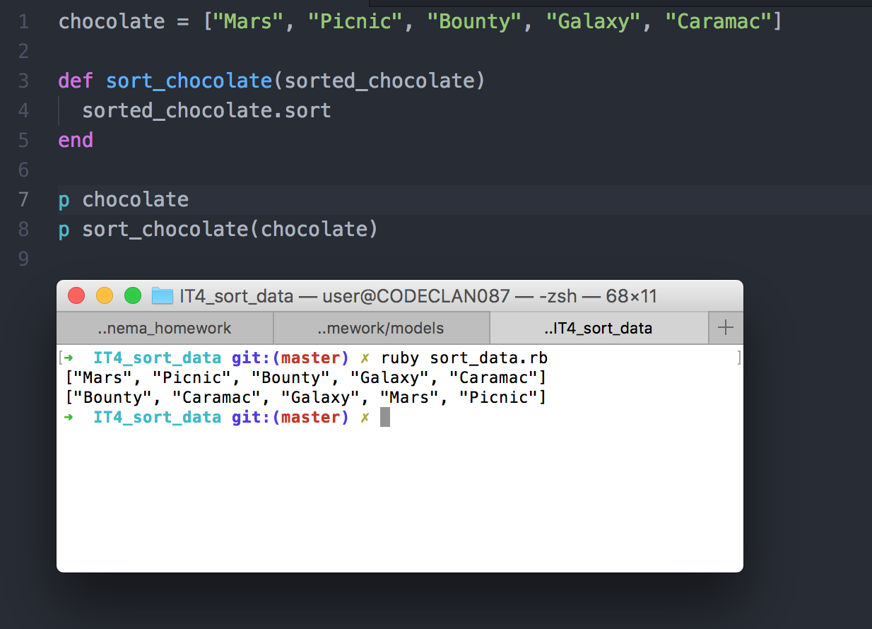

**IT:5** - Demonstrate the use of an array in a program

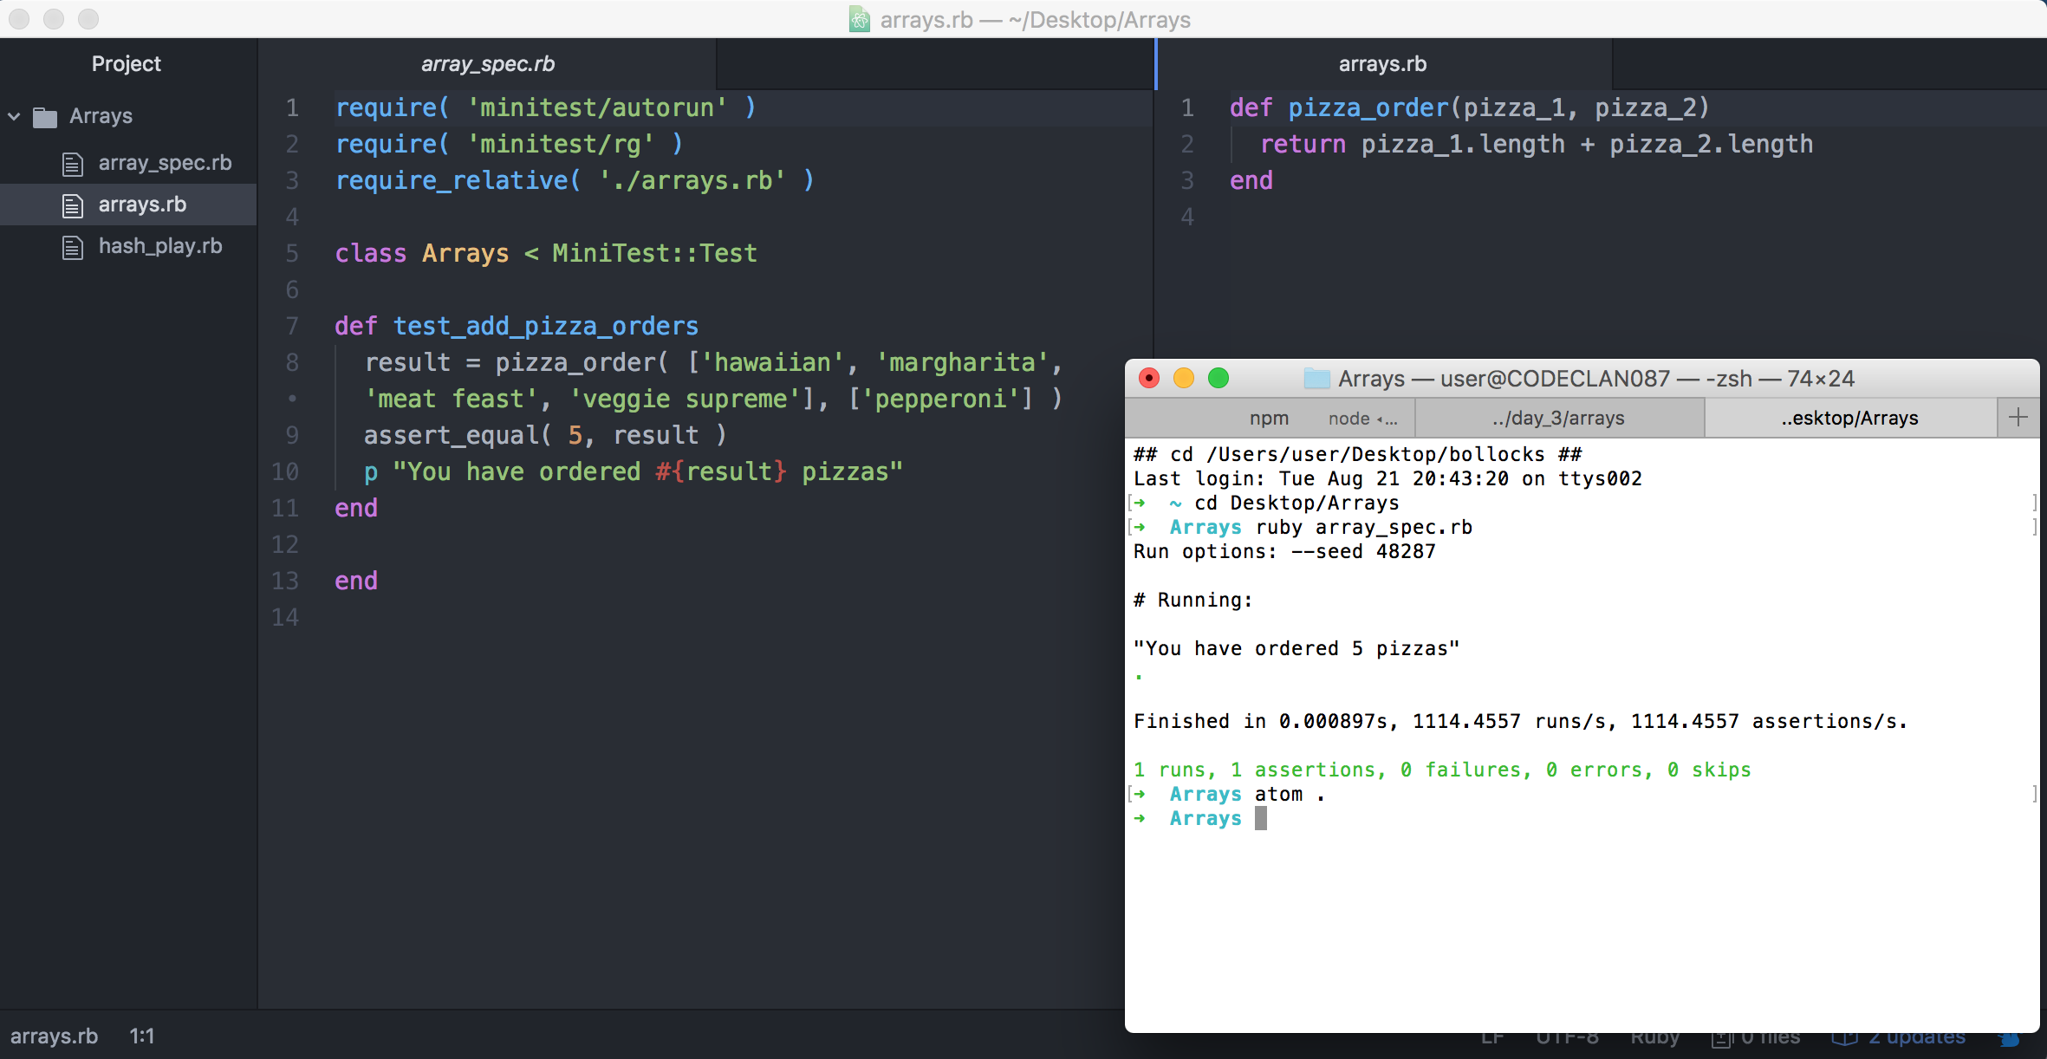

**IT: 6 - Demonstrate the use of a hash in a program**  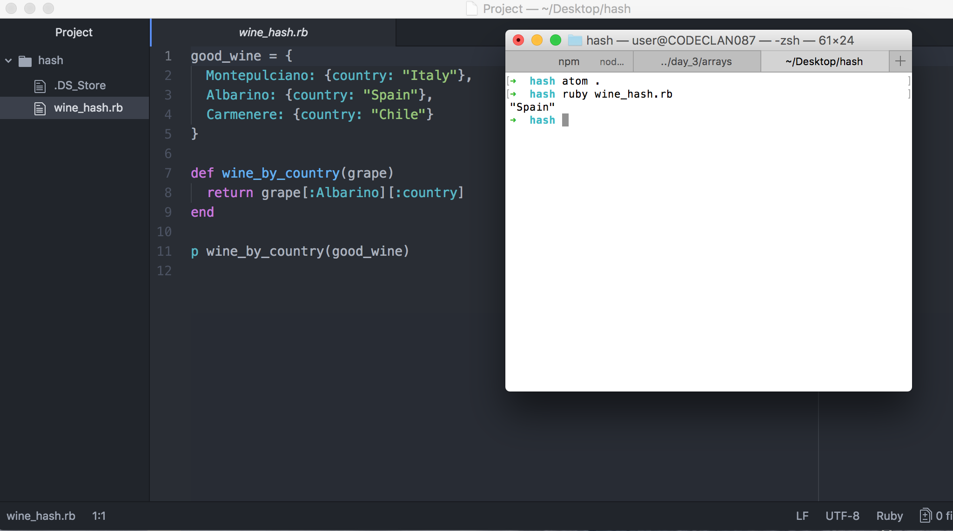



**IT:7**  **Demonstrate the use of Polymorphism in a program.**

**Screenshot 1: In the shop class the isell or sellable arraylist (called stock), which should take in different types of instrument that implement sell/sellable, such as a guitar or drum.**

**This screenshot should include this, plus a method that populates the arraylist by adding different types of instrument to the arraylist.**

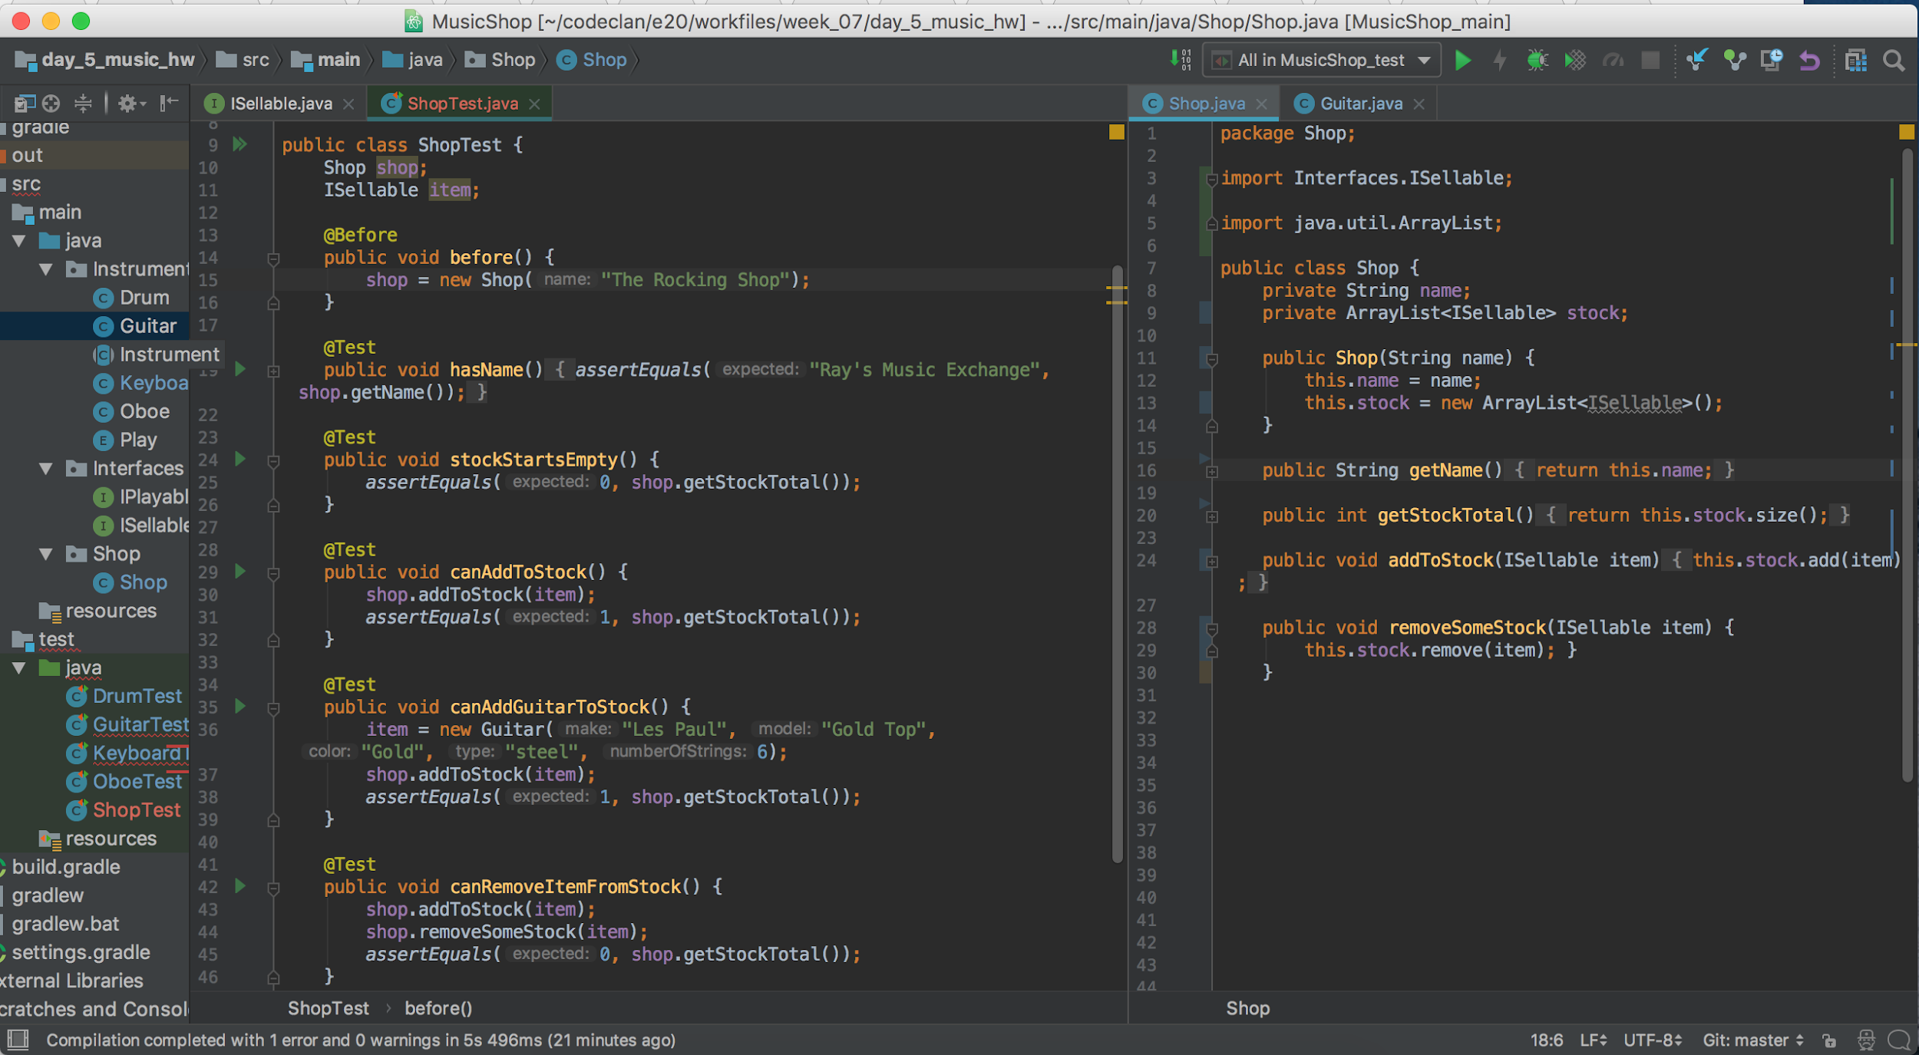

**Screenshots 2 & 3: Two different classes/types that implement the isell/sellable interface.**

**Screenshot 4: The isle/sellable interface.**

